# PRD: Pet’s Home

**Liuyi Chen, Chang Li, Yuyan Han, Yihong Liu, Xiaodan Hu**

**Date last updated: 12/05/2021**

## Vision

For anyone and any family, especially busy working professionals and retired elderly living alone who want some soft company from pets with easy access, pet’s home is a one-stop E-commerce platform that provides instant access to all varieties of pets with the most transparent transaction process and the safest after-sales guarantee. Unlike traditional pet stores or other E-commerce platforms for pets, Pet’s home provides extraordinary convenience, reasonable prices, and comprehensive selection by integration of all the resources from different merchants of pets and a self-built logistics system; transparent transaction process and safe after-sales guarantee by a well-established regulatory policy for qualified merchants.

## Motivation​​

## **Customer Segments**

● Possible pet buyer: Possible pet buyers are people who want to own a cute pet but can not find a way to get the pet matching them and their family. They may live in remote areas and there is no pet breeder near them. Or they cannot find a pet that can satisfy their all needs in the nearby breeders. Most of these people indicate that it is so inconvenient for them to travel to the breeders located in another place that they have to give up the plan. So, our hypothesis is that those pet buyers may be pleased to choose to buy pets online.

● Breeder: There are many small and middle type breeders in the country and are devoted to finding a way to be noticed by target customers. They are not satisfied by the possibility customers who live in their area can go to their home to pick up the pet and want to develop the network market. In the meanwhile, they cannot afford the expensive advertising fee because of their limited resources. Our hypothesis is that these breeders will go to our website if we provide an easy and economical way of the pet trade.

● Shelter: Shelters are organizations that have animals in their care and help them find new families. They always keep more than 100 animals in the meantime, which takes quite a lot of money and effort. If a pet is not adopted at a certain time, it will be euthanized. So, they want to find the adopters as soon as possible. Our hypothesis is that if we make this easy and wide impact, the shelters will be willing to use our platform.

### **Unmet Needs**

I believe potential pet buyers experience difficult transportation and limited choices when they choose ideal pets. According to our research, more than 40% of buyers need to drive at least 1.5 hours to get their dream puppy home. Meanwhile, some buyers are limited to local breeders due to a lack of transportation modes. The ease of Pet's Home's transportation can help them to expand their choices. Similar to potential pet buyers, breeders can expand their potential customers with the ease of transportation Pet's Home offers.

Moreover, the convenient and quick transportation Home's Pet offers can help to improve the pets market flow, which means more pets in the shelter can be paired with households. In this way, the shelters will not experience a huge burden to take care of a great number of pets at one time.

### **Existing Solutions**

Adoption from shelters: While people search online for a cat or dog, most websites recommend adopting one. People could easily find those websites, like Petfinder, PetSmart, or Petco. When you click the website, you can choose a dog or cat and input your postal code. Lots of pictures of pets could pop up and show their information. If you are interested in one, you could just follow the maps and meet the pet in person. Normally, adopting a pet costs about 300-500 dollars for donation. In this way, the breed of pet is random, which means most of them do not have pure breed and looks. Due to the abandoned history, the pets might have different personalities. Also, the age of the pet is random as well. Most of them are adults, but some of them are young.

Purchasing from locals: For purebred pets, people would choose to buy one, which usually costs 1500 dollars at least. People could just search the Pet store near me on google maps and drive there. Some local pet stores may have several dogs or cats available. If you want a certain breed like a golden retriever, they may not have it. Customers need to go to other stores. Or searching for a specific breed of dogs or cats, customers need to contact the cattery or breeders through the information posted online and make a reservation. Some breeders don't have young-aged pets. Customers usually need to pay around $500 for reservations and wait for a few months to get their pets.

Purchasing from online: Customers could search online for online breeders. There is one called Kittens Up for example, which seems very professional. But the price is over 2000 dollars without any registration for the breed. You could pay $500 for a reservation or just pay for the full price of the kitten. You could pick up the kitten until a certain date. But lots of pictures shown on the website are not the correct age of the kittens. There are several kittens that were born in October, but the photos of cat size are around at least 3 months on the website. Also, customers could not see the comments from previous buyers, which means people could not know whether the kittens are qualified from the information shown on the websites. Purchasing pets online may face many difficulties, fraud payment, pet transformation, or fraudulent pictures for pets.

### **Differentiation**

Unlike some other existing solutions that are more decentralized, and more like an intermediary website, they just provide some advertising information on the website to connect customers and business suppliers, which causes inconvenience, no access to after-sale warranty, inadequate information, etc.

We will not only provide a service similar to existing solutions but also integrate the best of these solutions in one place. The benefits of using a centralized system are significant in many aspects, for example, the customers can search in a more detailed way to find their desired pets, they can also talk and interact with their suppliers on the platform immediately, the pets would be cosigned with a self-built logistic system with 100 percent safety and speed. What’s more, they can also get the backup from the platform, which will make sure the merchants on the platform are qualified, verified, and responsible, with nothing to worry about.

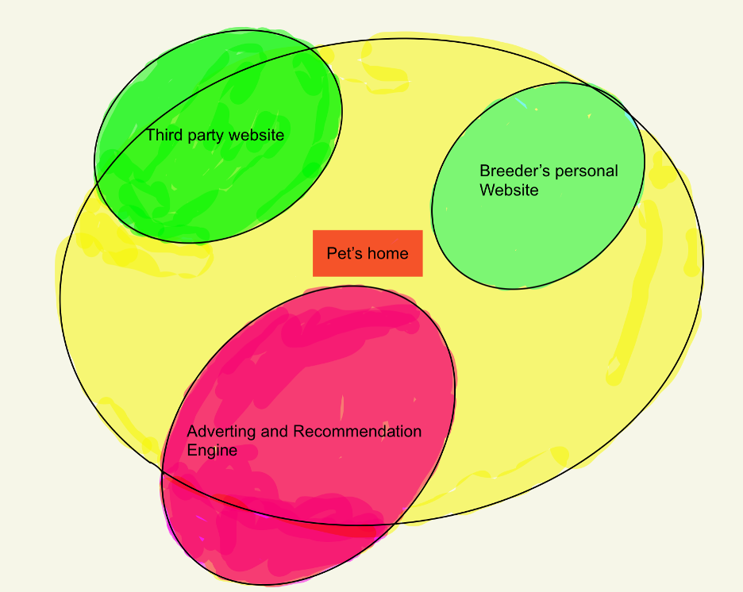

### **Why Now?**

Has anything changed externally or internally that makes this opportunity available to us now?

Since the outbreak of covid 19 in 2019, people nowadays have much fewer in-person social activities than before, but it doesn’t mean people don’t need any company anymore. However, people definitely need more companionship than ever after this horrible chaos. Pets are the perfect role that accompanies humans, with us. There is much data to prove that the number of purchases of pets is increasing rapidly year over year, especially after the outbreak of covid1, Pet’s home would be the ideal solution to improve the overall experience of those people who need a soft companion with the easiest and safest one-stop service.

## Storyboards & Verbal Walkthrough of Use Cases

**User Story 1 -- Hannah**

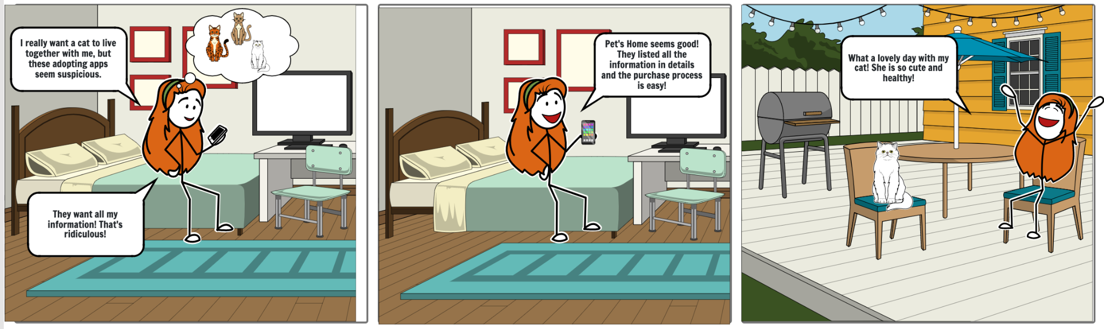

Hannah is a 22-year-old student studying Marketing in Seattle, Washington. She lives alone in an apartment and wants to find a lovely cat as a companion. Firstly, she plans to adopt a cat from Petfinder. However, she found out that she needs to submit too much private information on the website to complete the application and she felt uncomfortable about it. She wants to get a healthy cat because her friend’s cat is unhealthy and it took her a lot of money to treat it. When she searches on the Internet, she accidentally finds Pet’s Home. She finds this website perfectly meets all her needs. All the information and certifications about the cats listed in detail and the after-sale services make the websites reliable. Without hesitation, Hannah decides to use Pet's Home to find her future pets. Two weeks later, Hannah gets her dream cat! All the information is exactly the same as what’s on the website. She is very satisfied with this experience. Next time when her friends want to find a pet, she will definitely recommend Pet’s Home to them.

**User Story 2 -- Mike**

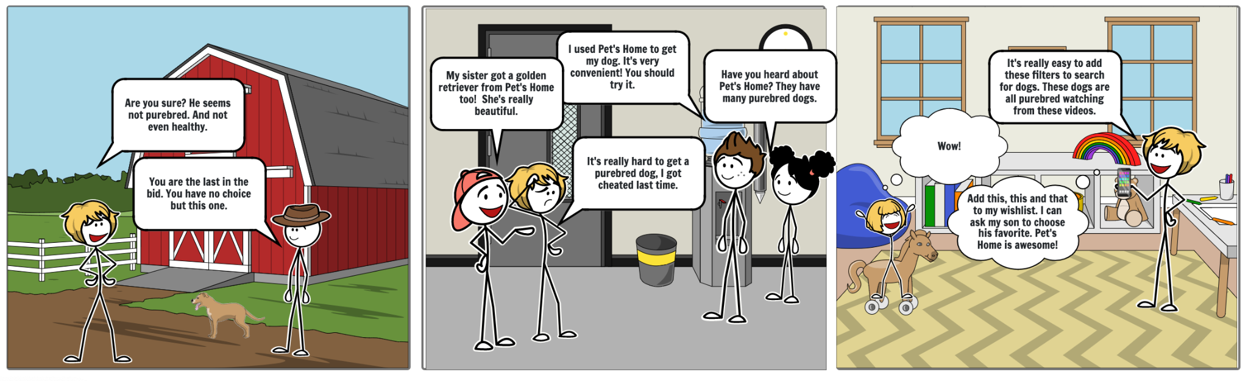

Mike is a 45-year-old Financial Analyst, he is married with two children living in Walnut Creek, California. One of his children wants to own a dog. Once his family was close to getting a dog; he preordered an AKC licensed unborn Labrador puppy half a year before it was born. But he was the fifth, which was the last to choose the puppy. He was not satisfied with the health condition and the appearance of that puppy. He expects to have a purebred puppy easily. Mike asks around his friends about how to get accurate information about pets, and a couple of them recommend Pet's Home. When Mike opens Pet's Home's App, he first creates a buyer account and puts on a filter of 'purebred'. When he browses the search results, he finds plenty of dogs

that satisfies his needs. So he collects all of them in his list and plans to discuss them with son later.

**User Story 3 -- Vera**

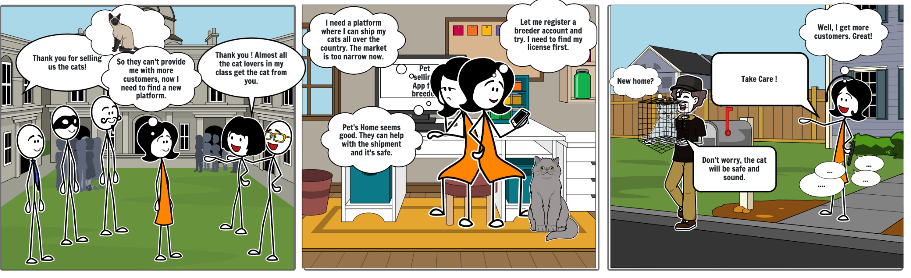

Vera is 30 years old and an undergraduate from UMass Boston. While she studied on campus, she met lots of potential buyers. After she has several cats at her home, many people want to buy the little cats. Then, she started her breeder career. She often sells cats through WeChat, a social media application. At that time, her target customers mainly focused on international students. Later on, Vera wants to expand her potential customers. She wants to sell not only to students around her but also domestically. Vera realizes she should find another platform instead of merely using Wechat. When she googles online, she finds Pet's home meets all her needs. The platform provides transportation, which allows her to expand her business market.

She registers a breeder account immediately and uploads related information about her cats. Two hours later, Pet’s Home sent her the notification that she is a qualified breeder based on all the documentation she uploaded and can start her business now. Five minutes after her first post, she received a couple of messages all over the country interested in her cats. She is busy replying to all of them. The next morning, when she wakes up, she sees that one of the customers in another state has already booked two of her cats. She is surprised by the results. She follows the instructions on the App for cross-state transportation. Three days later, she receives messages from the buyer that he gets the cats and likes them a lot.

**User Story 4 -- Jeff**

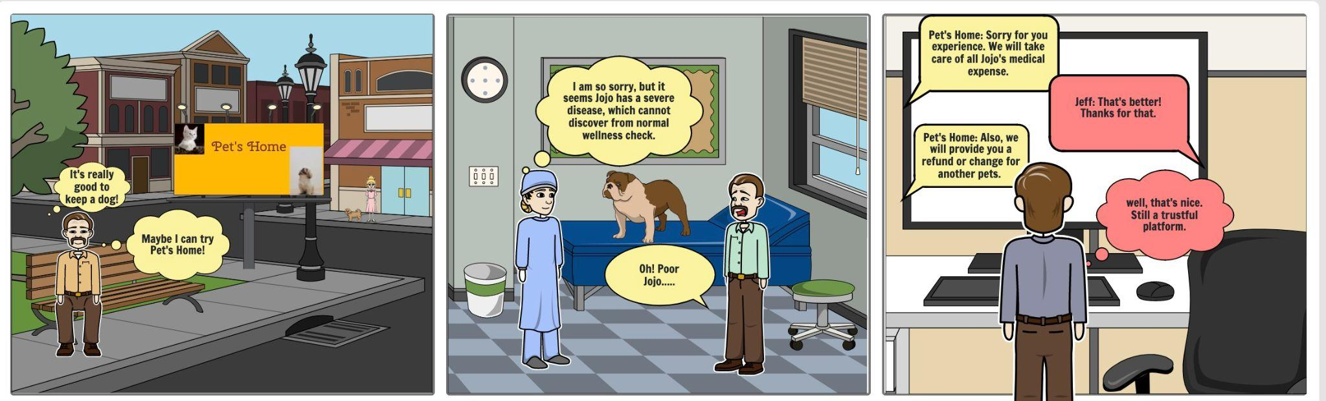

Jeff, a 50-year-old senior product manager, is from Wisconsin and works in Seattle. Even though he is surrounded by plenty of friends and co-workers in Seattle, he still feels lonely since all his family is in Wisconsin. He decides to give himself a birthday gift, a puppy as a companion. One day while he is waiting for buses, he sees the ads for Pet's Home. He decides to give it a try. He received his dog a couple of days later. However, his dog is in severe health condition only a week after he receives the dog (Jojo). Jeff brought Jojo to a nearby vet and was told by the doctor that unfortunately, Jojo caught a rare disease. The disease is hard to discover from a normal wellness check. Jeff reports the case to Pet's Home and uploads the report from Vet. One minute later, Jeff gets a reply from Pet's Home indicating that since Jeff gets Jojo within two weeks, Pet's Home will take care of Jojo's medical expenses. Pet's Home is also willing to refund Jeff or provide him with another pet. Even though there was an unexpecting situation earlier, Jeff is overall satisfied with Pet's Home due to its after-sale guarantee.

## 

## User Walkthrough & Visual of Use Cases

Buyer Mike: After installing the app, instead of asking Mike to sign up directly with his name, email address, etc. The app allows Mike to browse the page as a guest, the default page represents the recommendation list of different pets. If Mike wants to secure his account instantly instead of browsing the pets as a guest, he can click the account icon on the bottom-right of the application.

## 

Home page:

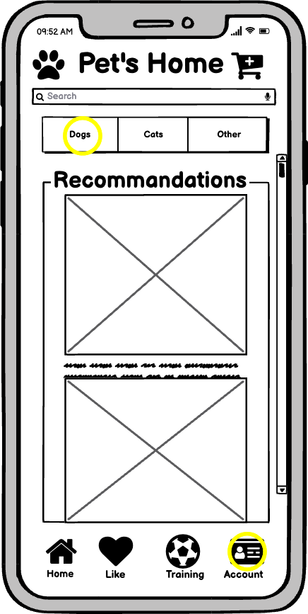

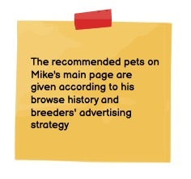

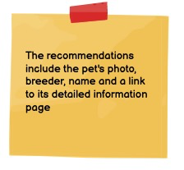

After Mike clicked the “account” icon, then he was directed to the “Account” page, at which he can register or sign in(if registered before) with his personal information, such as email address, payment method, name, etc.

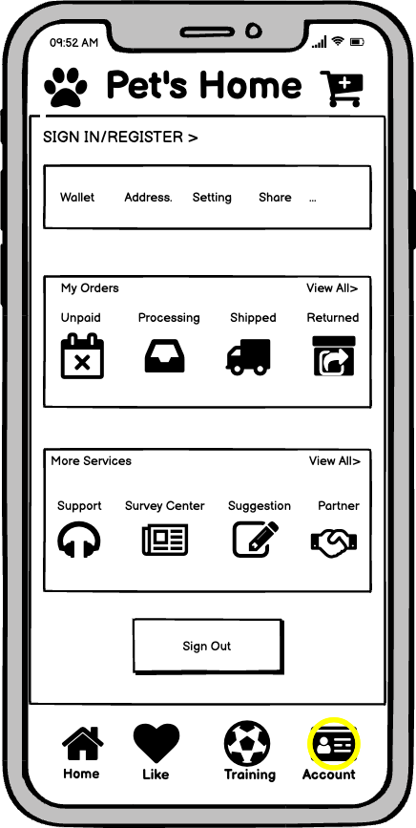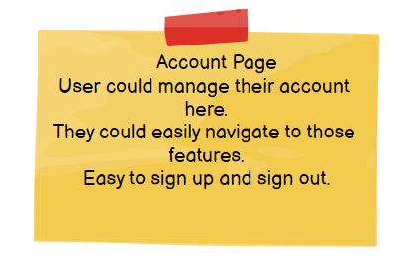

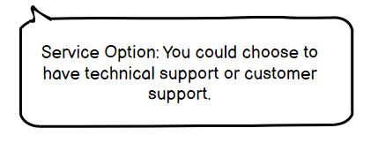

After setting up his information, Mike gets back to the home page and clicks the “Dog” button on the home page, he will be directed to the page that contains only dog pets with images and names, Mike can scroll down to randomly browse the list of dog pets, or Mike knows what kind of dog pets he wants with specific requirements, such as color, breed, size, etc. He can click the filter button to find out all the dogs that meet his requirements.

Dog result page:

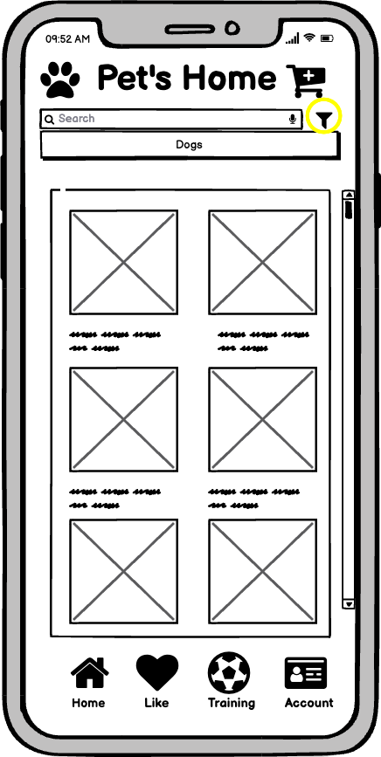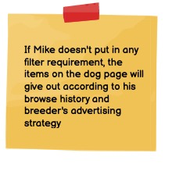

After Mike clicked the “Filter” icon on the top-right. Mike was directed to the page that pops up with constraints of different categories, such as size, age, sex, color, etc, for Mike to select for. For example, Mike wants to find a dog that is medium size, in baby age, female sex, black color. With the filter function, he can get the result of all the dogs that meet the requirements he just selected easily. What’s more? The buyer can also limit the dog within the range of chosen breeds he prefers through the “+” button on the top side. If Mike is done with the filter setup, he can click the “Done” button, and Mike will be directed to the result page with all the dogs that meet the requirements.

Filter main page:

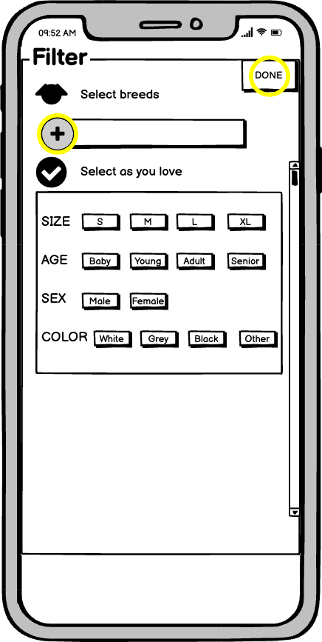

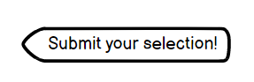

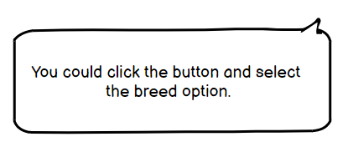

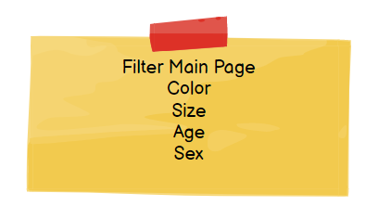

After Mike clicked the “+” button to select the range of breeds, he is directed to the page offer a list that includes all the common and popular dog breeds available, he can select one breed at one time, after Mike selects one breed, he can click “Done” button to return the “Filter main” page, then he can choose to add extra breeds or click “Done” button in the “Filter main” page to return “Dog result” page with those constraints.

Filter breeds page: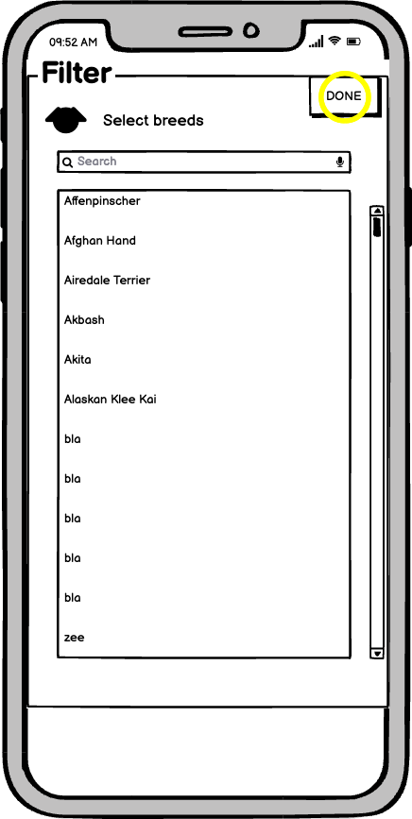



After returning to the “Dog result” page with those constraints, Mike started to browse all the dogs that meet the requirements by scrolling down the page, then Mike found the desired pet dog but he still wants to know more details about it, then he clicked the image of the dog, and the page of detailed information about the dog pops out.

Dog result after filter page:

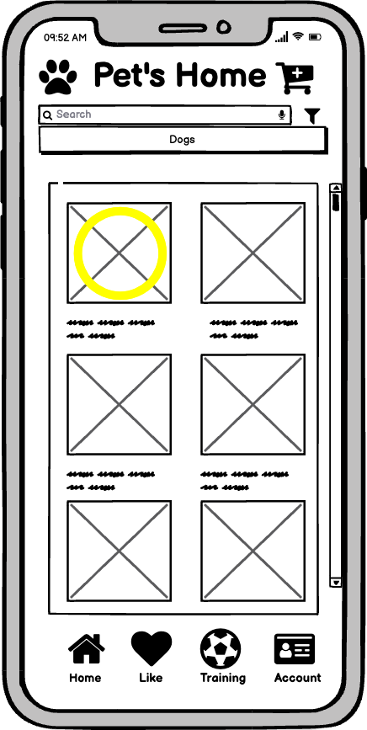

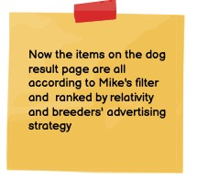

In the detailed page of the dog, Mike can swipe left or right to see more photos or videos of the dog. Below the sliding window, Mike can view all the details of the dog, such as price, name, breed, gender, etc. Furthermore, if Mike is satisfied with the information of the dog and willing to purchase the dog, then he can click the “ADD TO CART” button on the very bottom to add the dog into the cart.

Pet info page: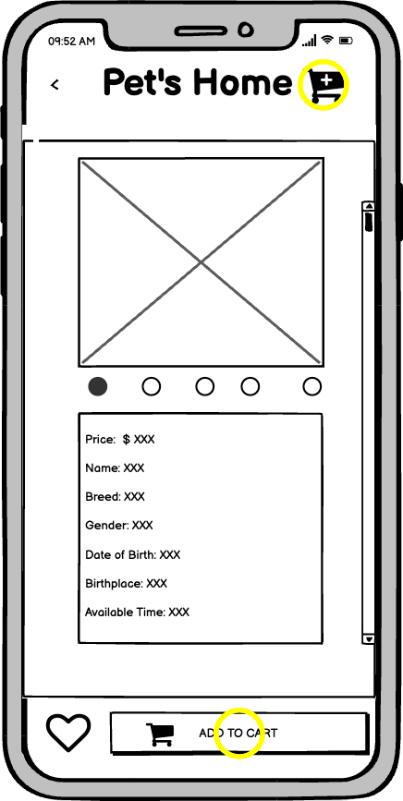



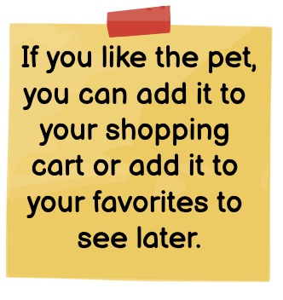

After Mike added the desired pet into his shopping cart, Mike wants to continue to check out this purchase, then he noticed the “Cart” icon on the top-right of the Pet info page naturally, and he clicked the icon, he was directed to the “Shopping cart” page, in the page, he can proceed to check-out the purchase instantly or he might change his mind about the purchase for now so that he can click the “Add to favorite” for later purchase. (Similar with save for later option in traditional e-commerce platform)

Shopping cart page:

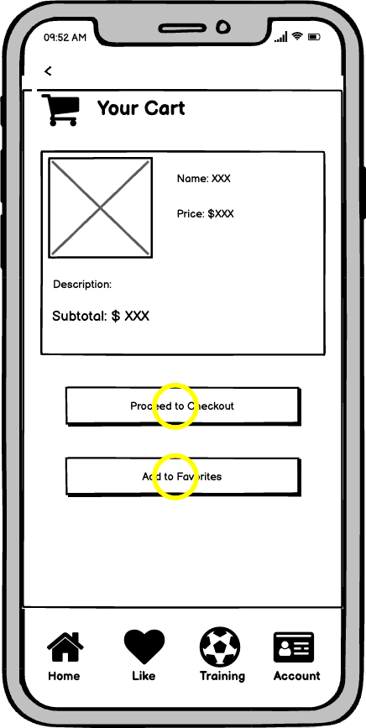

Mike is determined to purchase the desired pet instantly, so he clicked the “Proceed to checkout” button, then he was directed to the “Checkout” page where he was supposed to fill out the basic information for completing the purchase, such as the shipping address, the delivery method, payment method, etc.

Checkout page:

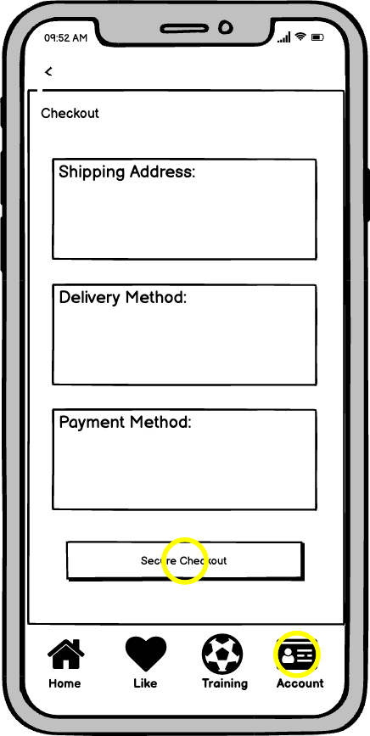

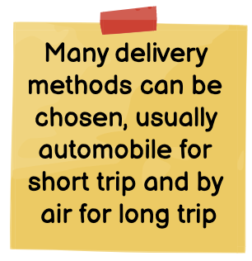

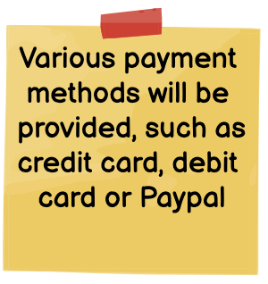

After Mike secured the order, now he cares most about the order status of the purchase, thus, he clicked the “Account” button on the bottom right to check the order status, and he can choose the “Shipped” status button inside the “My orders” section since he already paid the order.

Account my orders page:

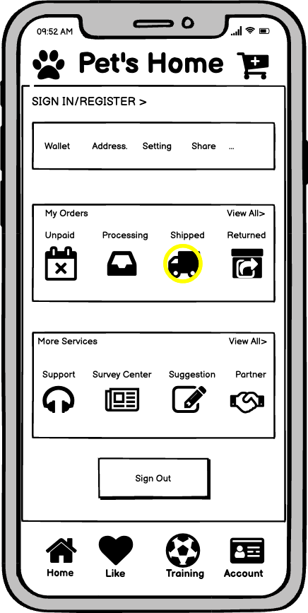

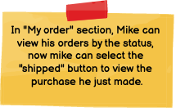

The Shipped order status page represents all the orders that are shipped with the pet’s image and a few basic information. The first order is the dog Mike just purchased and paid for, so he decides to click the image of the dog to check out more details about the order.

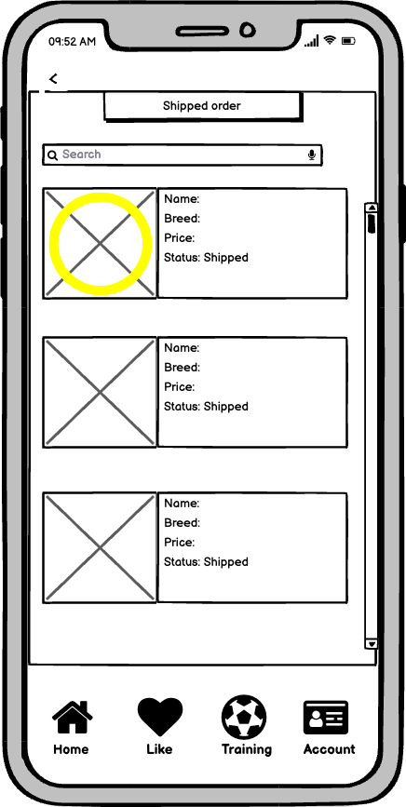

Shipped order page:

On the “Order detail '' page, Mike can browse much information, such as the dog’s basic information, the estimated delivery time, the return policy for this order, etc. What’s more, if Mike is interested in writing a review or decides to return the order, he can do so.

Order detail page: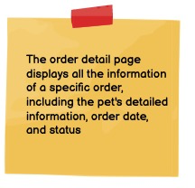

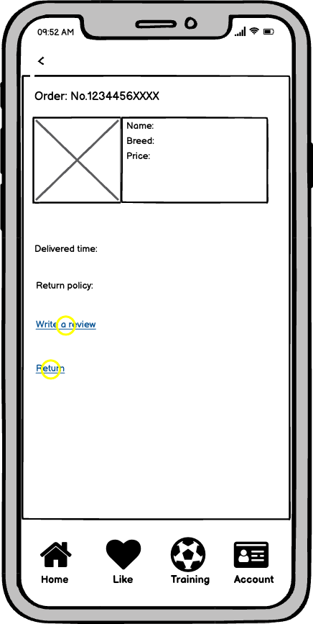

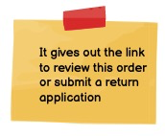

On the return page, Mike can add more details about requesting the return, he can add reasons, he can add more descriptions, he can also upload videos or photos to support his return request. Then he can click the “Submit” button to submit the request.

Return page:

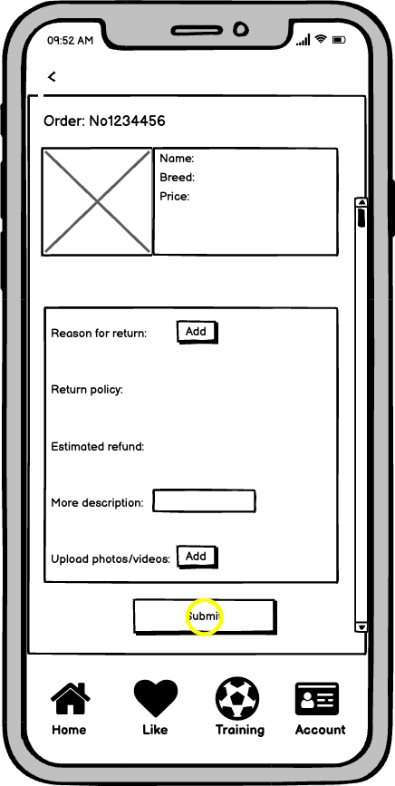

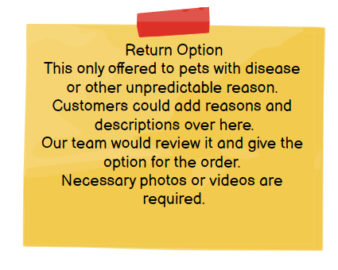

On the review page, Mike can write comets for this purchase, he can talk about whatever he wants about the order, no matter it’s about the purchasing experience, or pet’s quality, delivery speed, etc. After filling out all the review information, Mike can click the “Submit” button to submit his review of the order.

Review page:

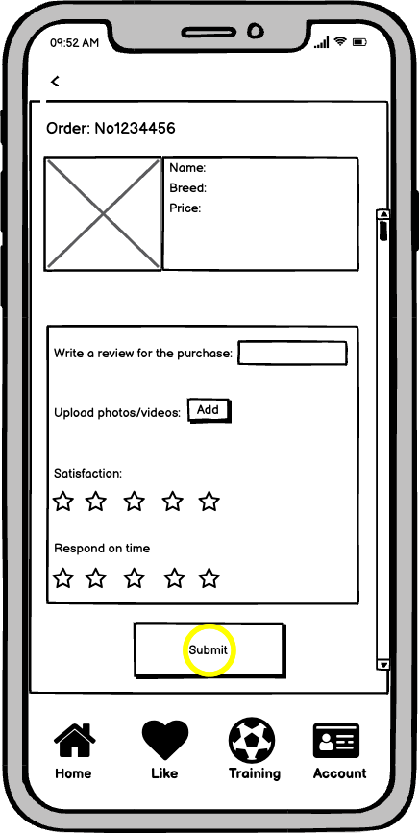





After everything is done with the order stuff, Mike can finally play with his puppy. However, Mike is a new dog parent who has no experience with petting or training a dog, thus he opens Pet’s home again and clicks the “Training” button. In the default “training” page, the content is all about the articles on training pets. Mike can scroll down to find the articles that can help Mike to train his dog. If mike is tired of reading too much, he can then click the “video” button to view more visual content.

Training article page: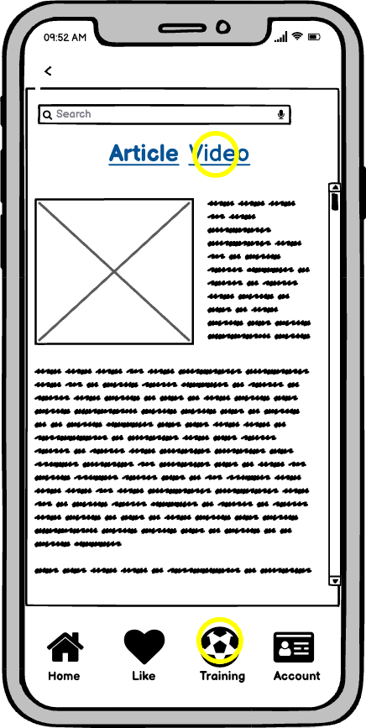



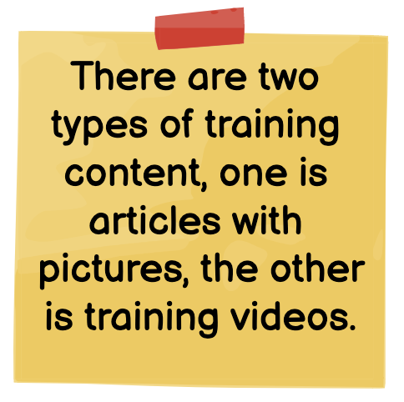

In the training page video section, mike can watch as many videos of training as he wants by scrolling down the page.

Training video page:

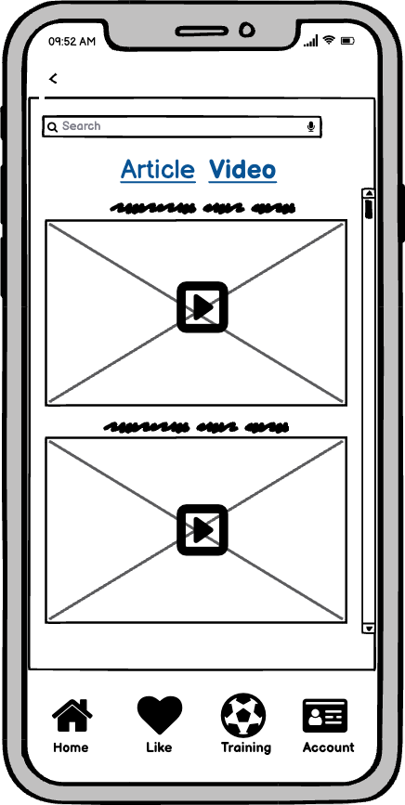

Seller/Breeder Vera: After installing the breeder version of Pet’s home, Vera was directed to the register/login page automatically. Since Vera is a first-time user on the platform, she clicked the “Register” button without any hesitation.

Breeder login page:

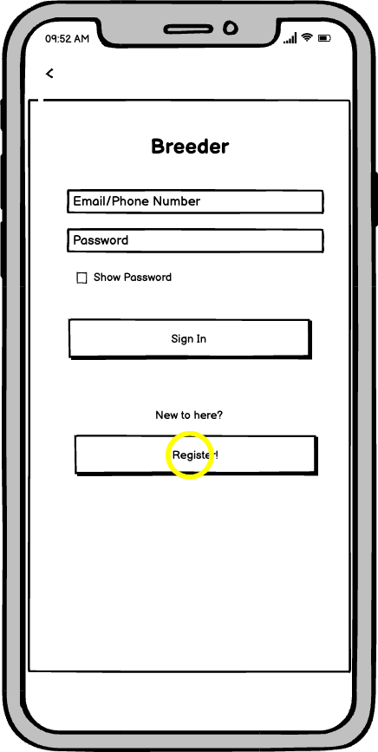

On the registration page, Vera was required to fill out much basic information, including credentials of breeding, range of pets for selling, breeder name or company name, email, etc. after lucy filled out all the information, she can click the “Apply” button to submit all the information, the platform will take a few days to process his registration request.

Breeder registration page:

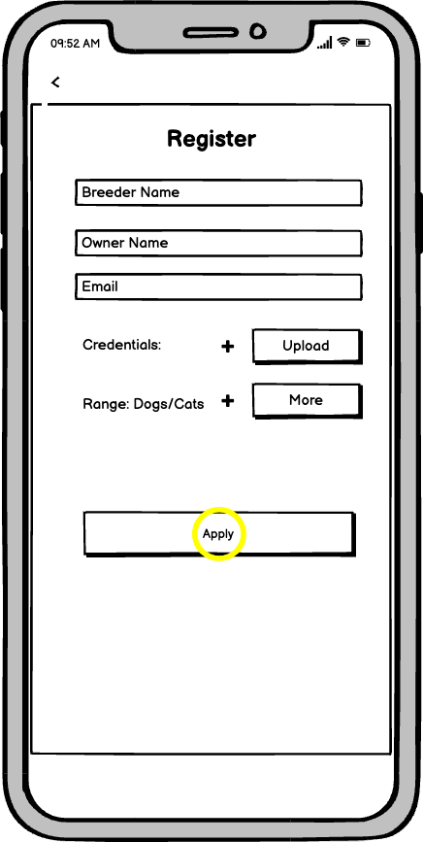

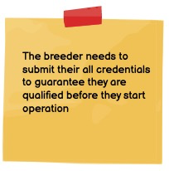

After a few days of waiting, Vera finally got approval from the platform, now she became a legal breeder on the platform to sell her pets. After she logins to the app, she is navigated to the default page, “Pet available”, where she can check all the pets on her e-store, she can add more pets by filling out the “adding pet” information box. After she is done with filling out the basic information of the pet, she clicks the “Post” button, then the new pet is available on the platform, all the buyers have the chance to look at it.

Breeder adding pet page:

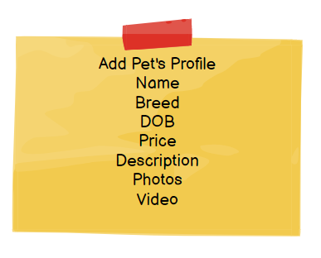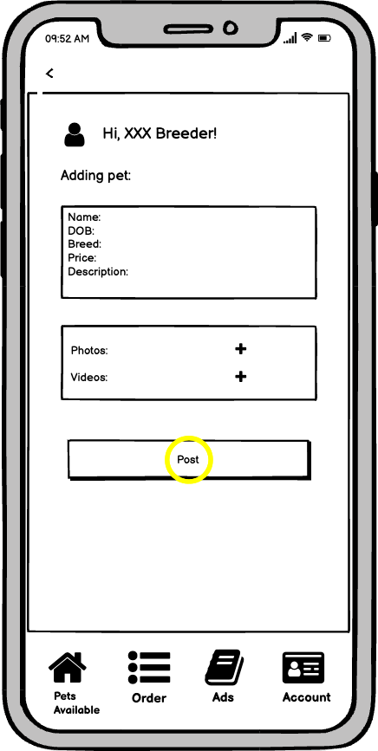

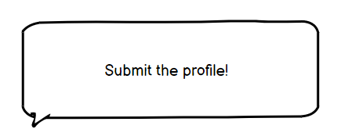

## 

## Detailed Design & Feature Description

**Design Principles:**

Our main idea of creating the Pet's Home application is to help people choose their pets more conveniently and easier with comparable prices, here are our design principles:

1. User friendly
2. Design for majority
3. Payment security
4. Focused on pets
5. Intuitive to users
6. Consistent
7. Data security

**Breeders:**

|  |  |  |  |
| --- | --- | --- | --- |
| **Feature** | **Details** | **Dependencies** | **Priority** |
| Register | Breeder name  Password  Owner’s name  Owner’s DOB  Owner’s sexuality  Owner’s contact information(phone number/ email address,etc)  Owner’s bank information  Address of breeder  Breeder’s preference | The dependency is to send a text message to verify the user’s contact information and connect to the bank to verify the saving account information. | p0 |
| Login | Breeders can use a pair of usernames and passwords or phone verification codes to log in. | The dependency is to send a phone verification code by text message | p0 |
| Verification | Breeder’s credentials  Breeder’s history  Breeder’s pictures and videos | The dependency is to relate the verification to the breeder account. After the backend processed the information and verified it from different verified websites/offices, breeders could add pets’ profiles under the account, which the data would store in the secured data company. | p0 |
| Add pets’ profile | Pet’s brief information (name, sexuality, age, DOB, location, color. etc)  Pet’s photos and videos  Pet’s breeder  Pet’s price  Pet’s purchase option and delivery means | The dependency is to relate to google images to guarantee the photos are not fake | p0 |
| Breeder main page | Navigate to orders page, data page, add pet’s page  Brief breeder’s information  Pets available |  | p0 |
| Order page | Display all the orders’ detailed information (order number/ order date/ pet’s information / customers’ contact information) and order management buttons | The dependency is to send messages to customers if the breeder has the need | p0 |
| Order cancellation | Breeders can cancel a specific order and end the transaction if the related pet is not available anymore. |  | p0 |
| Order Closed | Breeders can close a specific order if they believe the pet is delivered to the customer. | The dependency is to relate to the delivery company website to get the status of order delivery | p0 |
| Data page | Display the data, graphs, and analysis (paid for ads)  Display the sale data, user reviews, page views for each pet. (all breeders) | The dependency is to have data and graphs for each pet’s profile of page views, which are analyzed by the data group and stored in the secured data company. Within the ads function, breeders could see a huge increase in the number of page views. | p1 |
| Advertisement page | Allow breeder to apply advertising service  Display the chart and data of advertising effectiveness during the period  Give the expectation of sales data if breeders continuously advertise. | The dependency is to use MLE algorithms to calculate the expectation for lasting advertising. | p1 |
| Message page | Display the list of chats with customers.  Click an item to see all the messages with a specific customer. | The dependency is to use a sensitive vocabulary shielding system to filter impolite messages. | p0 |
| Logout | Breeders can access the logout function in all pages. |  | P0 |

**Customers:**

|  |  |  |  |
| --- | --- | --- | --- |
| **Feature** | **Details** | **Dependencies** | **Priority** |
| Login | Customers can use a pair of usernames and passwords or phone verification codes to log in. | The dependency is to send a phone verification code by text message | p0 |
| Create Profile | Customer basic information (name, DOB, email/phone, password) | The dependency is to store the user information in the data center and make it easy for users to access their accounts. | p0 |
| User main page | Search bar  Pet’s type  Recommendations  Home button  Like button  Training button  Account button |  | p0 |
| Account page | User name  Address  Payment  Order information (navigate to order in process, order shipped, order reviews, order returned)  Other services (navigate to technical support, customer service, suggestions)  Button for Logout | The dependency is to secure customers’ information in the safe data center depending on the term of the use and legal approval. Users could easily manage their address and payment for faster checkout, which was verified by the bank for the checkout availability. | p0 |
| Filter | Breeds selection (by alphabetical order)  Pet’s size  Pet’s gender  Pet’s color  Pet’s personality  Pet’s age  Pet’s location (breeder location) |  | p0 |
| Navigation of all results | A list of pets’ profiles according to the filters  Pets’ brief information (name, DOB, gender, breed)  Photos of pets |  | p0 |
| Pet’s information | Display the pets detailed information (  pet’s name/  pet’s sexuality/  pet’s age/  pet’s breeder/  pet’s price/  pet’s DOB/  pet’s location/  available delivery means/  pet’s photos/  pet’s video/  pet’s parents information, etc ) |  | p0 |
| Add to favorite | Customer can add a specific pet into his collections in each pet’s information page |  | p0 |
| Like page | Customer can navigate their favorite pet in the like page from every page |  | p0 |
| Shopping cart | Pet profile in shopping cart (delete function, save for later)  Proceed to checkout button |  | p0 |
| Checkout | Customers can choose the order delivery date, delivery means, terms of payment  Customers should complete their address information,  payment information | The dependency is to verify the availability of the payment information with the assistance of bank system | p0 |
| Orders page | Display the brief information (order number/ order date/ pet’s breeder/ order status, etc) all the orders under the customer’s account and each link to their order management page |  | p0 |
| Order management page | Display the detailed information (  order number/  order date/  pet breeder/  pet name/  order status/  pet price/  customer address/  customer payment information.etc  ) of a specific order  Provide link to review and return function |  | p0 |
| Review | Allow customer to review the breeder, by rating and writing comments |  | p0 |
| Return | Allow customer to submit a return application, with choosing a return reason |  | p0 |
| Train Page | Search bar  Articles  Videos  Photos | The dependency is useful articles and videos from other websites, which need to agree to the terms of use and approval by different authors. | p1 |
| Share | Pet’s order  Customer’s name  Pet’s age  Time for having the pet  Messages/Photos/Articles customer would share | The dependency is that the customer needs to agree the application could use the photos/articles for noncommercial use. | p2 |
| Log out | Customer can log out in the account page and end all the service |  | p0 |

v1 aka Minimum Viable Product (MVP)

All features above which are in priority 0 are all minimum viable products in this product.

vNext

* All the features above listed as priority 1 and priority 2: referring to advertising service, sales data analyst service, training service and interaction service.
* Import in auto reply customer service.
* Allow customer pay via PayPal and Venmo.
* Allow customer pay by installments.

* Upgrade the data analyze report by using more sales strategy models.
* Upgrade the training service to provide a one-to-one guide.

v Long-term

Our long-term plan would be focusing on the pet’s accessories in the mobile application. After customers make orders on our website, we could offer other services for our customers instead of just helping them choose the right pet. We want to add pet’s foods, pet’s treats, pet’s clothes, pet’s supplies, and even pet’s hospital service as well. This could make our customers choose the products for their pets especially important to the new pet’s owner.

## Roadmap / Timing

Our application is focusing on the pet market becoming easier for people who want to have a pure breed pet. Our first launch would make our customer able to select and purchase the pet with guarantee. We plan to launch our first version in April, 2022.

|  |  |  |
| --- | --- | --- |
| Milestone | Timing | Notes |
| Beta version- breeder version available | March, 2022 | Breeder only: Able to sign up, submit the credentials, add pet’s profile, verify the bank account, ship the pet with our cooperated company |
| First launch-customer version available | April, 2022 | Customer: Able to sign up, search bar available, able to see the pet’s profile, add to cart, proceed to checkout, review the orders, set up the payment method, edit address, contact breeder through app |
| Analyze the application and make upgrade-customer version | May, 2022 | Analyze the user experience, make changes on the pages as necessary, collect more feedbacks |
| Analyze the breeder version | June, 2022 | Able to check the order status, take the order, cancel the order for unpredictable reason |
| Analyze the feedback and metrics-breeder and customer version | August, 2022 | Ensure the functions working both on the breeder version and the customer version, make changes as necessary |
| Launch the second version-breeder version | September, 2022 | Add advertisement and analyze feature, breeders could make changes on their sale strategy |
| Analyze the second breeder version-feedback and metrics | October, 2022 | Make changes as necessary, analyze the feedback from the advertisement feature and numbers of using the analyze features |
| Launch the second version-customer version | November, 2022 | Add the training page, work with the professional company |
| Analyze the metrics-the second customer version | December, 2022 | Make sure the existing features available for breeder and customer version, make changes if necessary |
| Upgrade the second version-customer version | January, 2023 | Add the share method, make changes on the training features if necessary |

## Metrics

|  |  |  |
| --- | --- | --- |
| **Quantitative Metrics** | **Breeders** | **Customers** |
| Number of downloads | × | × |
| Daily total value | × | × |
| Average order value | × | × |
| Number of sign-up users | × | × |
| Daily number of purchases of pets | × | × |
| Average clicks per page for each selling pet | × |  |
| Session length | × |  |
| Number of daily active users | × | × |
| Number of available pets | × | × |
| Conversion rate of user to purchase users | × |  |
| Number of returned orders | × | × |
| Rate of returned orders to all orders | × | × |
| Bounce rate | × |  |
| Cart abandonment rate | × | × |

**Qualitative metrics:**

* Top landing pages
* Top exit pages
* Most popular pet breeds
* Social media / share button stats
* Top referring URLs
* Visitors’ browsers
* Location of visitors
* Consumer feedback and engagement
* Brand trust
* Traffic source

## International

When we start our business, we focus on the domestic area since we believe there is already a huge market with plenty of potential. Admittedly, internationalization brings us more opportunities and profits.

However, we need to consider all the regulations and related laws meanwhile. Moreover, overseas transportation and health monitoring of pets during the transportation process could be challenging. Starting a business is all about facing challenges and finding solutions to all the challenges. We have strong faith that we could solve all the related difficulties eventually to provide services to worldwide customers, however, at the same time, we do not believe the cost is worthy at the early stage.

Based on our previous calculation, the domestic market provided us a considerable revenue while we are confident in each process of transportation and related regulation. At the same time, we believe we can provide our services to our Canadian customers due to geography and law regulations. According to our research, there are approximately 7.9 million cats and 5.9 million dogs in Canada. This huge market and potential could enrich our community and provide broader choices to our customers. Moreover, expanding our business to Canada could be our first step to internationalization. It could gain experiences for our future steps.

## Projected Costs

Below is the total development cost for the launch of MVP version:

* Cost for app development and test: 10 person month
* Cost for app test: 5 person month
* Cost for web design: $10,000;
* Cost for development space rental: 500 squares = $1,000 / month * 5months
* Cost for development environment and test environment: $500 / month * 5 months
* Cost for production environment: $1,000 * 2 months
* Total projected costs = 9,022 * 10 + 7,217 * 5+ 10,000 + 1,000 * 5 + 500 * 5 + 1,000 * 2 = $149,105

Assumption

* The whole MVP version product will take 5 months to complete. We will have 2 development engineers and 1 test engineer working for the whole process. And 1 month before launching, we will hire and train a customer service;
* The salary for development engineers is $9,022 / month according to the average salary for SDE in Seattle;
* The salary for testing engineers is $7,217 / month according to the average salary for testing engineer in Seattle;
* We will get a UX design plan from a website design agency instead of hiring a UX designer because it can save the cost during launch period;
* We will rent Amazon cloud service for development and test environments during the whole process and complete our previous work here. And 2 months before launching, we will rent Amazon cloud service for formal products.

## Operational Needs

Operational assistance is important for Pet’s Home’s Long-term success, these areas may include:

Application Development

* In order to do the Pet’s Home’s mobile App development, a technical expert with similar backgrounds will be hired. In our early stage, the expert will lead a small team to develop the Pet’s Home app which includes basic functionalities like searching, filtering, placing orders, checking out, returning, etc.
* An experienced UX design agency will coordinate with our development team to ensure the easy use of the app for customers. Good user experience will bring more new customers to our app through mouth to mouth in the long-term.

Domestic Pet Breeders

* In the beginning, we will contact domestic licensed pet breeders to sell our concepts and get them to join our app. We will not only sell the idea, but also listen to their objections so that our service can better meet their needs through updates.
* Getting referrals from pet breeders who join is an important way to get more breeders involved in our early stage. Pet’s Home should have enough suppliers to ensure that there is a large selection of pets for users to choose from.

Marketing

* Our app will include both online and offline promotions. We will hire a social media expert to determine where and how to promote our app to attract new customers and new breeders. We will also coordinate with the local pet community for physical promotion of our app.
* Our customer service team should be fully trained to fulfill the customers’ needs. They should have the basic knowledge of pets and know how to respond to customers to raise the satisfaction of our app. Our customer team is an important source for us to get feedback and also deliver our brand concept. We want our existing customers to bring us more new customers.

Pet Experts

* We will coordinate with pet certification verification experts to ensure that our certification verification procedures are feasible and standardized. All breeders in our app must be verified to start selling.
* If the pet’s health condition is not the same as described or the pet has an unexpected problem, the pet expert in our team will consult with the breeder.
* The training articles and videos on our training pages will come from the pet training experts and dedicated writers we work with.

Pet Shipment Partnership

* Pet’s Home will partner with domestic airlines to ship customers’ pets for long distance travel. Our agent will help the breeders to make reservations, check-in and coordinate with the airlines to make sure of the safety of the pets.
* Pet’s Home will partner with local ground transportation companies to transport clients' pets for short trips. The entire experience should be a higher level of service designed for pets, including monitoring, on-call assistance and low-stress environment.

## Addressing Caveats/risks

What are possible failure modes? For example:

● Privacy concerns?

This platform gathers customer information, including email account, physical address, payment methods, qualified ID, etc. we will need to ensure a secure system that does not reveal customer privacy, both seller and buyers.

● Legal risks?

We want to make sure we are not violating any laws regarding selling live animals, managing the animals, etc. Also, we want to make sure we are not violating any laws regarding collection of personal information of users.

● Dependency?

Our platform requires a strong connection with pet’s suppliers, partnerships shipment, and relies on the favorable policy for supporting pet ownership.

|  |  |
| --- | --- |
| Risks | Mitigants |
| Privacy risk | Store and encrypt personal and transaction information in a security data center. |
| Legal risk | ​​Fully consider legal risks with legal counselor at launching |
| Dependency | Partnership with other transportation companies for pet shipping in the beginning and develop our own line of pet transportation services. |

## Team Members

Yihong Liu: wireframe walkthrough, caveats/risks, vision, Metrics

(571)-376-3220

[liu.yiho@northeastern.edu](mailto:liu.yiho@northeastern.edu)

Chang Li: Detailed design & feature description, roadmap, Metrics

(206)-670-6885

[li.chang2@northeastern.edu](mailto:li.chang2@northeastern.edu)

Yuyang Han: Operational Needs, Storyboard, Metrics

(206)-310-2348

[han.yuy@northeastern.edu](mailto:han.yuy@northeastern.edu)

Liuyi Chen: Detailed design & feature description, projected cost, Metrics

(206)-214-6787

[chen.liu@northeastern.edu](mailto:chen.liu@northeastern.edu)

Xiaodan Hu: Storyboard, international

(206)-620-4685

[hu.xiaod@northeastern.edu](mailto:hu.xiaod@northeastern.edu)